The Five Mages

DESIGN DOCUMENT
By Horpel for the 2023 April Pirate Software Game Jam

Introduction 2
Game Summary Pitch 2
Inspiration 3
Player Experience 3
Platform 3
Development Software 3
Development Environment 4
Genre 4
Target Audience 4
Concept 4
Gameplay overview 4
Theme Interpretation (against the rules) 6
Primary Mechanics 7
Secondary Mechanics 8
Art 9
First iteration 9
Second iteration 9
Audio 14
Music 14
Sound Effects 14
Game Experience 15
UI 15
Screens 15
Controls 15
Development Timeline 15
Must haves 15
Nice to have (dropped) 15
Planning 16
Planning for solo development 17
Documentation 18
Project files 18
Quotes to Use 18
Spent time 19
Day 1 - 01.04.2023 - 5.5h 19
Day 2 - 02.04.2023 - 3h 19
Day 3 - 03.04.2023 - 3.5h 19
Day 4 - 04.04.2023 - 0h 19
Day 5 - 05.04.2023 - 4.5h 20
Day 6 - 06.04.2023 - 6h 20
Day 7 - 07.04.2023 - 6h 20
Day 8 - 08.04.2023 - 3h 20
Day 9 - 09.04.2023 - 3.5h 20
Day 10 - 10.04.2023 - 1h 21
Day 11 - 11.04.2023 - 7h 21
Day 12 - 12.04.2023 - 8.5h 21
Day 13 - 13.04.2023 - 2h 21
Day 14 - 14.04.2023 - 8h 21
Day 15 - 15.04.2023 - 10h 21
Total time for MVP 22
Bugs 22
Changes 23

Introduction

Game Summary Pitch
The Five Mages is a tower defense game, about five mages, placing and upgrading towers around a pentagram to catch all emerging goblins from the portals within the pentagram before they can leave the pentagram.

Inspiration
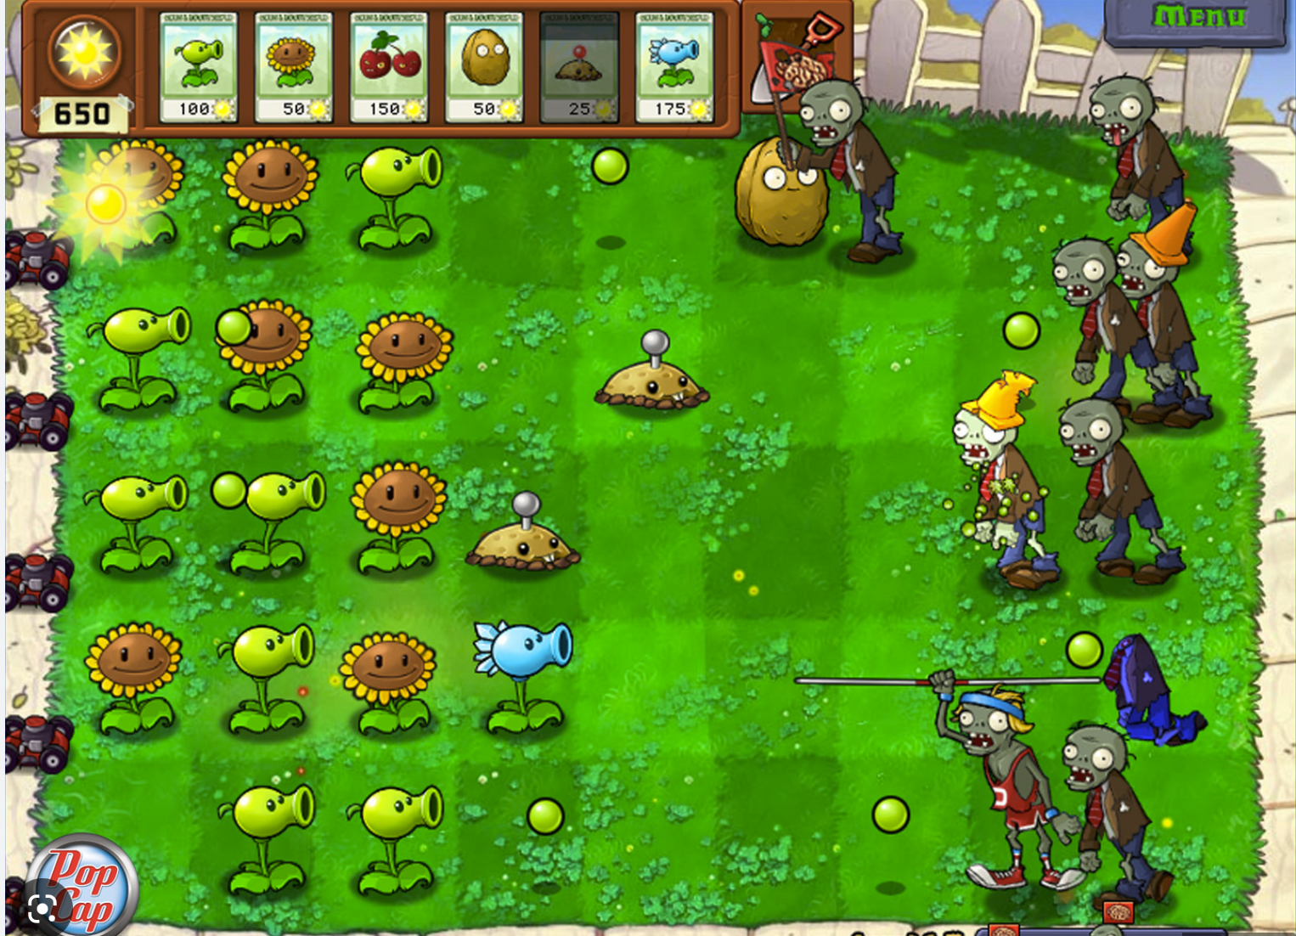
Plants Vs. Zombies
Plants vs. Zombies is one of the most known Tower defense games around.

Player Experience
The player must defend the waves of goblins coming through the portals with the help of the right kind of magic through magical towers the mages can erect. The waves are increasingly harder to fight and the towers have to be upgraded. To build and upgrade the player must use the five mages and command them around the pentagram.

Platform
The game is developed to be released on itch.io (webGL), windows and mac

Development Software
- Unity 2021.3.22f
- Visual Studio
- git
- GarageBand
- jsfxr
- Audacity?
- Blender?
- Gimp?
- Inkscape?

Development Environment
- Mac Studio, running 12.6.2 Monterey release
- HD Cam for recording / streaming
- Keyboard, Mouse, Spacemouse, Trackpad, mini midi Keyboard for optimized app input
- Nas-Server for project backups / storage
- Github for source code publication and version control
- Google Drive for GDD

Genre
Singleplayer, tower defense, casual

Target Audience
Casual players who like strategic elements

Concept

Gameplay overview
The game takes place on a single screen. Central to the scene a pentagram with portal-like structures on the opposing inner edges is shown. The player can select one of the five mages floating around the pentagram and command him to build or upgrade towers somewhere at the outside of the pentagram. Each tower is of the same kind of magic as the mage who build it:
- Fire (red)
- Earth (green, formally brown)
- Air (white)
- Water (blue)
- Spirit (yellow)

The goblins emerge in waves from the portals in the center and are trying to leave the pentagram through one of the outer edges, matching their magic. Each goblin has a random magic and each edge of the pentagram has an assigned magic.

The magic is aligned:
- water against fire
- fire against air
- air against spirit
- spirit against earth
- earth against water

Each killed goblin leaves an amount of energy, going into the reservoir of energy all mages share to build new towers and upgrade old towers. Killing a goblin is done through the goblin entering the area of the magical tower. As the magic is ordered around the pentagram, each magic is next to two other magic and opposed to two. If the goblin is for example red (fire), it will move to the red edge of the pentagram and try to leave it from there. The goblin will be highly vulnerable to water and air magic and only halved vulnerable to spirit or earth magic. If the goblin comes into the range of a fire tower, he will gain health.
Upgrading towers increases their magic strength and range.
Building and upgrading requires the mages to move to the tower around the pentagram and to perform a magic dance which takes some time. The time gets longer with each level of the tower.
Goblin waves are increased by the number until the wave count is divisible through 7, then the number of goblins is reduced, the strength and speed is increased.

Fun Fact: all counting is done as multiples of 7!

An announcer tells you about the next wave, number of goblins and strength, and speed to expect, as text overlay and/or spoken (don't know how to do yet). After each wave, the player gets some extra energy and time to upgrade the towers.

Theme Interpretation (against the rules)

The rules are pretty simple, the player must build enough towers of each magic to fight the goblins. The towers of different magic are not allowed to overlap in the range of their effect circle. The game forbids overlapping placement and upgrading is prevented if the growth of a circle would lead to overlap. The game emphasizes through an overlay or spoken word on the separation of magic elements every time you try.
However, the player can, and need to, overlap two, three, four or all magics if he builds the towers at the right positions and start upgrading all of them at the same time, as the goblins will become way to fast and to healthy very soon. Connecting towers will result in much more effective towers and a narrator will do laments over what the player is doing. (“How dare you!”, “All of you are goblins!”).
As more Towers are connected the intensity of the resulting magic is multiplied. Connecting is done through overlapping chains, no direct overlapping is needed. Tower A overlaps with B and B overlaps with C counts as a chain.
If the player manages to connect five towers, the game will instantly be game over as the player has unleashed the doomsday event.
If the player does not connect the towers, he will fail fast, as the waves are getting harder very fast, making them unbeatable with only single magic towers.

Primary Mechanics
- Selecting a mage from the five mages around the pentagram by clicking on it.
- While a mage is selected and enough energy is available, build a tower by clicking the tower icon and choosing a place outside the pentagram by clicking. The tower will appear and show its initial circle of effect, accept or reject with the buttons next to the tower.
- While a mage is selected and enough energy is available, select a towers upgrade symbol to see its increased stats and range, accept or reject with the buttons next to the tower.
- Looking at the stats of a tower by clicking on a tower. The stats will be displayed next to the tower, as well as the stats and costs of a next upgrade.
- Destroying a tower by selecting it and using the trash symbol next to it. Trashing a tower requires the mage to go to the tower and recovers some of the energy used to build and upgrade the goblin.
- Killing goblins by placing towers around the pentagram to avoid the escape of the goblins to the world. Each goblin is bound by a specific magic and has a visible health bar, or maybe a dissolve effect, indicating the remaining health of the goblin. Killing the goblin leaves a portion of energy, which is used to build and upgrade towers.
- Losing because a goblin has left the pentagram.

Secondary Mechanics
- Connecting two or more towers through upgrading at the same time. As the mage needs time to walk to the tower and more time to upgrade the tower, the player can select all mages and upgrade the tower to form overlapping areas of effect after the upgrades finish. If two towers get connected that way, an energy beam forms between them and the stats are increased.
The combined magic are:
  - Fire + Spirit = holy fire (more effective)
  - Fire + water = cleansing steam
  - Fire + Air = hot flames
  - Fire + earth = magma
  - Earth + spirit = holy earth (more effective)
  - Earth + water = pulling swamp
  - Earth + air = tornado
  - Air + water = ice
  - Air + spirit = holy winds (more effective)
  - Water + spirit = holy water (more effective)
- The second level combinations are:
  - Fire + Spirit + water = holy steam (more effective)
  - Fire + spirit + air = holy flames
  - Fire + spirit + earth = holy magma
  - Fire + water + air = thunderstorm
  - Fire + water +earth = burning swamp
  - Fire + Air + earth = fire tornado
  - Spirit + water + air = holy ice
  - Spirit + water + earth = holy swamp
  - Spirit + air + earth = holy tornado
  - Water + air + earth = sinking earth
- The third level combinations are:
  - Elemental curse if no spirit involved
  - Holy curse otherwise

Art

First iteration
The iteration will only contain simple objects as placeholders for the pentagram, the mages, the goblins, the towers, and portal, and only the most basic things like line renderers between the towers to indicate connected and towers and goblins to indicate health drain or gain.

Second iteration
Ideas and concepts for various parts:

Mage | 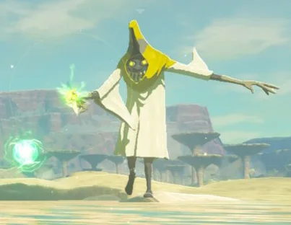  https://www.ign.com/wikis/the-legend-of-zelda-breath-of-the-wild/Electric_Wizzrobe  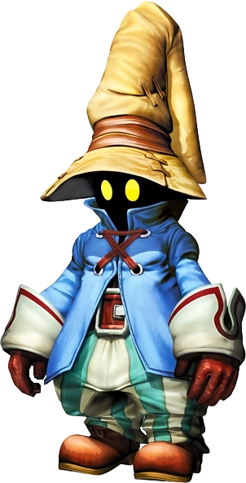  https://finalfantasy.fandom.com/wiki/Vivi_Ornitier | The mage should be a mixture of the mages seen in Zelda: Breath of the Wild and the character Vivi Ornitier from Final Fantasy 9. The color of the hat is the magic the mage belongs to. The mages moves in a dancing and jumping way. Making small lights whenever they hit the ground: https://youtu.be/A6bCTP1ibmI?t=94
Goblin | 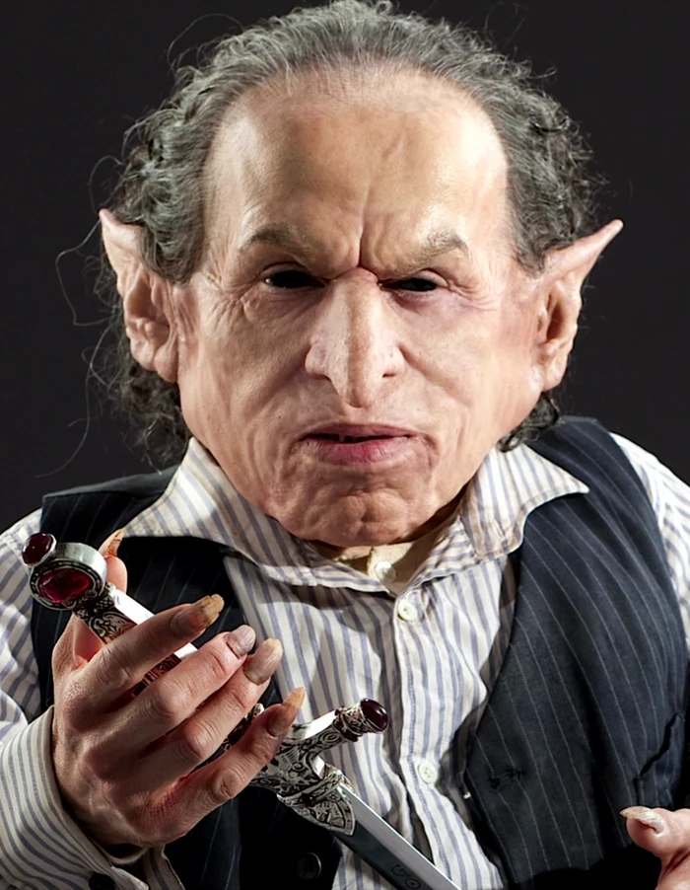  https://harrypotter.fandom.com/wiki/Griphook  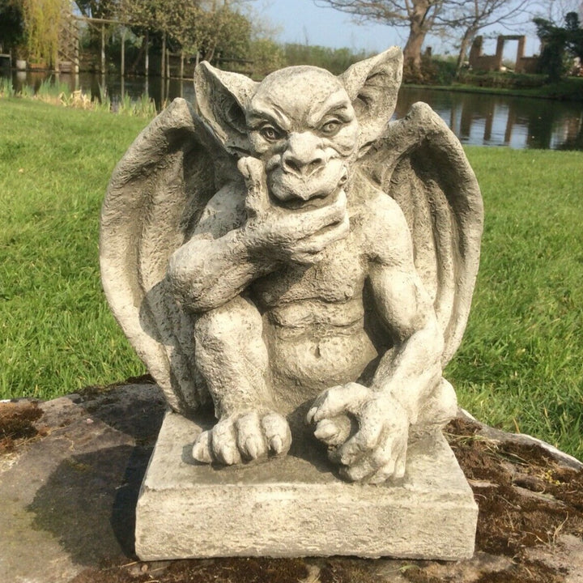  https://ferneyheyesgardenproducts.com/products/stone-garden-winged-goblin-gremlin-gargoyle-troll-ornament-on-base-1 | The goblin is a mixture from the greedy Harry Potter styled, gold hungry Goblin, living deep down and hoarding the treasures and the mystical goblins living through the day as stone sculptures, mostly on the roof edges, angrily doing their goblin business during the night.  The goblin is slow at first, orienting in the world to find the right magic. It should have wings, colored the same as the magic. Once the goblin finds the direction he starts rumbling forwards with increasing speed to the edge of the pentagram.  The goblin enters the world with a reverse dissolve effect, the same effect might be used to indicate his rest health until death.
Tower | 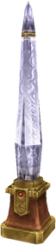  https://finalfantasy.fandom.com/wiki/Crystal_(term) | The towers are magical crystals, colored by the magic they possess, standing on the ground and grown through the upgrades.
Connection beam | 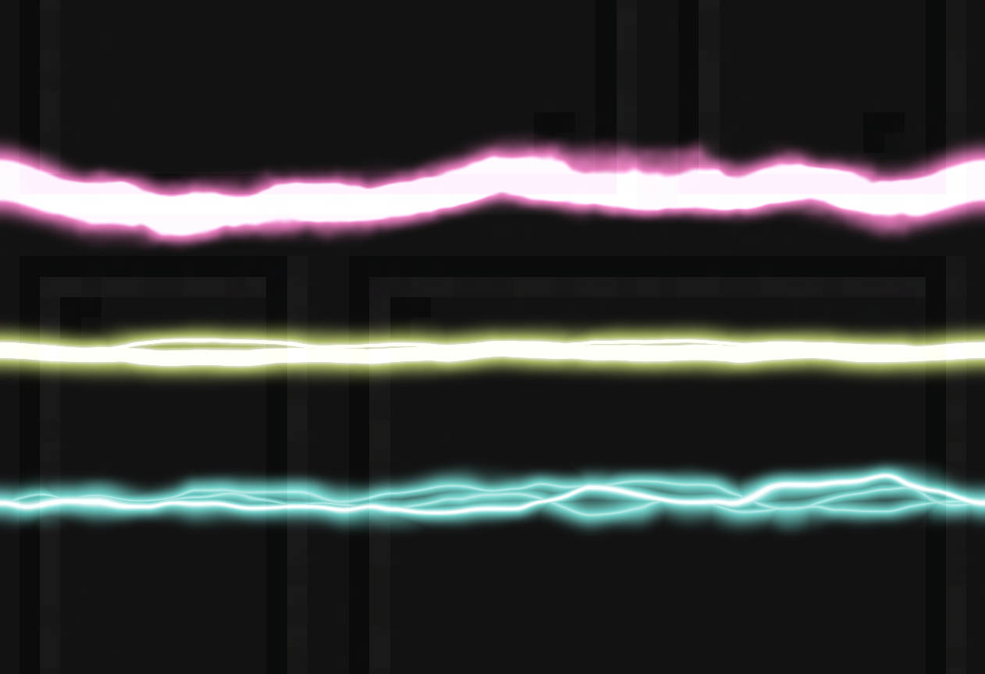  https://godotshaders.com/shader/energy-beams/ | Something like the reference image. Dangling, getting brighter(whiter) and straighter, if more towers are connected. If possible as color gradient between the two connected towers colors.
Health / Attack beam | 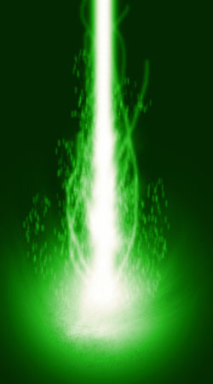  https://www.deviantart.com/illmaster/art/Energy-Beam-84938079 | A pulsating beam in the color of the magic. For mixed magics the beam becomes faster pulsating and of whiter color. If the Tower is giving the goblin health (wrong tower) the pulse should be reversed and the mixed beam gets darker, blacker.
Pentagram and background | 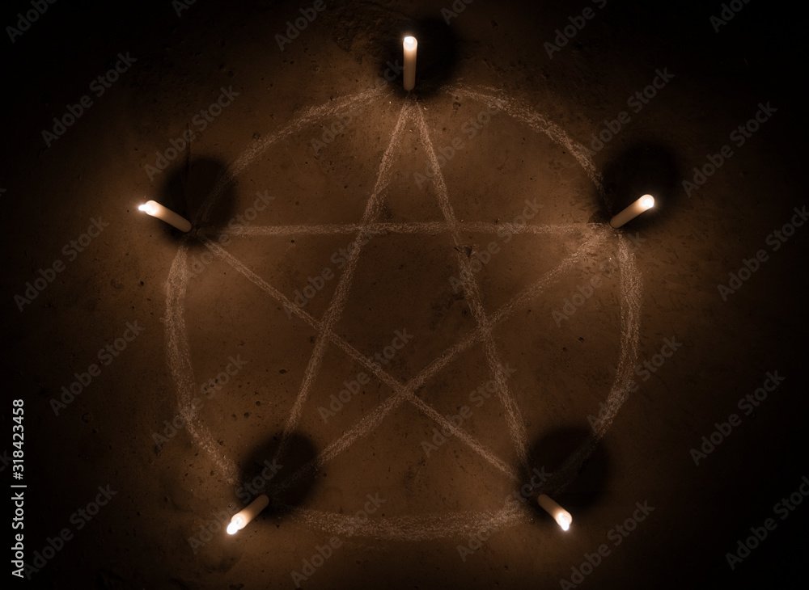  https://stock.adobe.com/de/images/white-pentagram-symbol-on-concrete-ground-illuminated-with-candles-dark-background-scary-mystical-occultism/318423458 | Brownish earth, dark surroundings with a simple whitish pentagram on the ground. The five candles flames are colored in the magic colors making a weird color shadow
Portal | 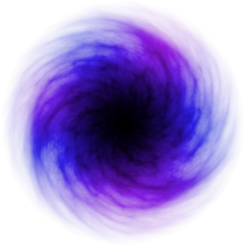  https://technicpack.fandom.com/wiki/Portal  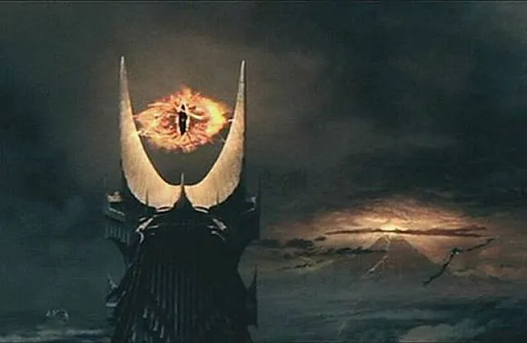  https://lacan-entziffern.de/objekt-a/saurons-blick/ | The portal is like the eye of sauron in a storm and a hint to the greater evil lurking behind the portal.
Doomsday | 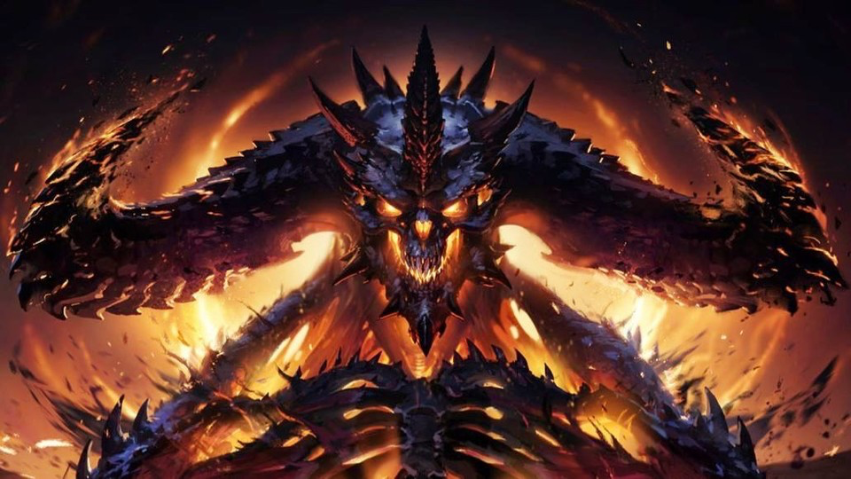  https://www.gamestar.de/artikel/diablo-4-diese-klasse-spielt-ihr,3389563.html  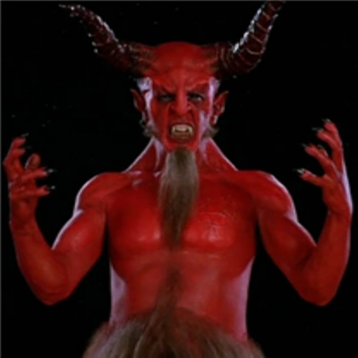  https://villains.fandom.com/wiki/Satan_(Tenacious_D) | Like good old diablo prime evil daemon. OR a little more funny like from Tenacious D.  No in game appearance, only on doomsday screen.

Audio

Music
Fiddling around with GarageBand and treating the results as music with emphasis on the mute button in the main and pause menu.
- Beat1 for the game running
- Maybe something brighter for the game menu? TODO
- Maybe something more brutal for doomsday? TODO
- Maybe something angelic for game over? TODO

Sound Effects
Sound effects are currently made with jsfxr, see json files in assets for serialized version for use with https://sfxr.me/
First round of experiments resulted in:
- Death
- Beam
- Select
- Arrive
- Upgrade / build

What sounds are missing?
- Maybe jump / move sound for mages
- General improved sound quality / other tool for sound generation

Game Experience

UI
Simple buttons and text, based on TextMeshPro and Canvas. Optional with hand drawn graphics.

Screens
- Welcome screen to start the game, sound settings
- Main game scene with energy level at top and iconic buttons next to selected mage or tower.
- Pause screen with sound settings
- Gameover Screen with achieved score
- Doomsday screen

Controls
Mouse movement and left mouse button / touch input

Development Timeline

Must haves
- Game Design Document by 08.04.2023
- Minimal playable game with all screens and gameplay concepts by 15.04.2023 (Planning points 2 - 25 are considered mvp)

Nice to have (dropped)
- Nice title screen
- Animated mages
- Animated towers
- Animated goblins
- Different goblins
- Nice gfx
- Different gfx for each kind of magic
- Different gfx and sfx for higher level beams
- Nice audiotrack
- Nice sfx
- Animated doomsday (big daemon crawling out of the pentagram)
- Nice gameover screen

Planning

# | Topic | Due Date | Parts | Status | Time spent
1. | Fill in the missing parts of the Game Design Document | until Friday, 06.04.2023 |  | Mostly done | 4.5h
2. | Create basic level |  |  | done | 7.75h
3. | Create basic mages |  |  | done | 3h
4. | Implement mage movement |  |  | done | 8h
5. | Create basic tower |  |  | done | 8h
6. | Implement tower placement |  |  | done
7. | Create basic goblin |  |  | done | 3.5h
8. | Implement goblin spawning |  |  | done | 0.5h
9. | Implement attacking |  |  | done | 0.5h
10. | Add simple gfx to indicate attacking |  |  | done | 1h
11. | Implement scoring |  |  | done | 1.5h
12. | Add gameover condition |  |  | done | 0.5h
13. | Add energy adding and energy ui |  |  | done | 1h
14. | Implement upgrading |  |  | done
15. | Implement overlap detection |  |  | done | 0.5h
16. | Implement waves |  |  | done | 0.5h
17. | Implement announcer for waves |  |  | dropped
18. | Implement lamentor for overlaps |  |  | done
19. | Implement doomsday condition |  |  | done | 0.5h
20. | Add title screen |  |  | done
21. | add instructions screen |  |  | done
22. | Try to make some continuous noises like music |  |  | done | 2.5h
23. | Try make more noise counting as sfx |  |  | done | 1h
24. | Add settings to disable noise in main menu |  |  | done
25. | Add pause menu with sound disable option |  |  | done
26. | think about how to make it color blind friendly |  |  | dropped
27. | Do the optional / nice to have stuff |  | 0 of 11 | dropped
28. | Debugging | 15.04.2023 | 10 of 13 | started | 3.75h

Planning for solo development

37 items to be done on 15.04.2023.
About 4 - 6 items target per day to have more time for the harder items like animations, better ui, better models, more variation and nicer gfx.
All stuff related to sound should be done on each day as exercise.
Modeling should be done on each day of the second week!
Time per day not more than 2-3h each. This results in 30 minutes per item on start!
Pomodoro shall be used to enforce breaks and switch of Tasks. Nice Idea, not compatible with me!

Documentation
All development should be streamed live via https://twitch.tv/horpel/ and be uploaded to a Playlist on https://www.youtube.com/playlist?list=PL0UJUdK34mHTSDCp21z7oN47vcIYVvg81
This document shall be accessible all the time via https://docs.google.com/document/d/1fTuyL1MuHASvTflHPck6MaCSScTPIIPhTsU2SJiUkHg/edit?usp=sharing as read-only version.

Project files
All project files will be hosted in a git repository on github and made public once the jam is over. The repository will be available at: https://github.com/SandraK82/fivemages

Quotes to Use
- How dare you
- That’s no good
- You are all Goblins
- Can’t trust these Goblins
- It’s true

Spent time

Day 1 - 01.04.2023 - 5.5h
- Writing the initial version of the gdd - 2h
- Playing with sound effects on https://sfxr.me/ - 1h
- Experimenting with GarageBand - 2.5h

Day 2 - 02.04.2023 - 3h
- Making repository and some doc changes - 1h
- Installing latest unity version for apple silicon, setting up project - 1h
- More refinements on gdd - 1h

Day 3 - 03.04.2023 - 3.5h
- Leveldesign, Lights, Portal - 3.5h

Day 4 - 04.04.2023 - 0h
- Playing around with a new music keyboard - 0h (to the game progress, 10h to my lost time budget)

Day 5 - 05.04.2023 - 4.5h
- Goblins, spawning, many shaders, improvements to portal and first GameManager! 4.5h

Day 6 - 06.04.2023 - 6h
- Better portals - 1.75h
- Debug and Understand Lightning Settings for builds, trying around to get 10 lights working with no success, change visual style to adapt; much to learn about how to light in unity - 4.25h

Day 7 - 07.04.2023 - 6h
- Finalize last sections of gdd, from now only reporting and late changes in here - 1h
- Better appearance of the portals - 0.5h
- Made the mages in Fusion360 and spawn them to level, together with their lights - 2.5h
- Fighting with input system - 2h

Day 8 - 08.04.2023 - 3h
- More fighting with input system - 2h
- Made clicks work - 1h

Day 9 - 09.04.2023 - 3.5h
- Made the Mages move around and an indicator what can be done - 3h
- Fix turning of yellow portal - 0.5h

Day 10 - 10.04.2023 - 1h
- Some Towering - 1h

Day 11 - 11.04.2023 - 7h
- Making towers work a little bit, including placement prep - 7h

Day 12 - 12.04.2023 - 8.5h
- Balancing towers vs goblins - 2.5h
- Overlap conditions, doomsday, gfx - 3h
- Add Scoring with animation - 1.5h
- Add energy display and counting - 1h
- More gdd stuff, changes section - 0.5h

Day 13 - 13.04.2023 - 2h
- Fiddled with itch.io - 2h

Day 14 - 14.04.2023 - 8h
- Upgrade Mechanic
- More UI
- Bugfixing
- Making more Bugs

Day 15 - 15.04.2023 - 10h
- Build Mechanic
- Overlap Lamentor
- More bugfixing
- Rewrote selection/hit detection/clicking logic, much simpler now
- Cancel building added
- Audio
- Music
- Simple title , game, doomsday screens added
- Simple manual added to title screen
- Audio and music switches added
- Added black screen for quit on web version
- Repaired some selection bugs

Total time for MVP
Totally spent about 71.5h !

Bugs
- Lights in builds not working
  - Lights are working, only 2,4,8 in std settings of urp, no more than 8
  - hdrp has no webgl renderer, so try builtin
  - Built in has no shadergraph, back to urp
  - Nothing to do about, need to learn more about lights
- Portals turning wrong
  - Debug why mostly the yellow portal is crazy turning as hell
    - Was the angle problem..
- Portals pop into scene
  - Ease appearance, maybe use the dissolve shader with another setup?
- Lots of number crunching needed to get values of health, radius, speed, and damage right
  - Simplified original idea somewhat
- Mage can upgrade more then one tower same time
- Dissolver as upgrading does not work
  - Math gets more complicated when you are stressed
- Beam is not updating to mage location
- Tower build indication (hallowtower) is flickering
  - Damn those colliders on all simple 3d objects
- Upgrade tower not appearing after tower upgraded when still selected
- If a mage is below the build/upgrade/cancel button then it gets selected when button is clicked
- Blue circle for towers is drawn for some unknown reason above the pentagram
- Last Beam is not removed when waves finishes
- No deselect
  - Select tower, click somewhere

Changes
Some stuff has to be changed during the development to accommodate new thinking directions and to overcome my personal shortcomings:
- Making the game colorblind friendly is out of scope
- Adding of, at least a simplified, instruction screen will be mandatory as the games design is quite complex
  - The alternative was to make the first 5 levels/waves as an introduction with onscreen text and increasing amount of mages, starting with one portal and one mage, was dropped due to available time
- All the nice to have optionals ( Nice to have ) won't make it, maybe some sort of childish animation/graphic for the doomsday event
- Between waves there won’t be just a countdown ticking, it will pause gameplay to have time to order the mages around and make overlap building easier. The user must continue the gameplay once finished building and upgrading. After continue, the next wave will start immediately.

